**1.INTRODUCTION**

In this project, government needs to constantly monitor the academic progress of beneficiary’s right of scholarship from primary level to the post graduation level in order to link their academic progress with scholarship scheme on a digital platform. Consider set of criteria's to issue scholarships for the students, who satisfy criteria can be beneficiary of the scholarship scheme. Here we have three academic criteria's such as 75%-85% , 85% -90% and 90% above should get three category schemes of scholarships respectively. Hence, the students who are eligible for scholarship they must process the above said criteria.

**1.1. ORGANIZATION PROFILE**

SreeVidyanikethan Engineering College (SVEC) is situated in lush green and scenic surroundings, 16 km from the famous temple-town of Tirupati. Established in 1996, it has over the years produced many brilliant engineering students who have made a mark for themselves and brought laurels to the Country. The College is affiliated to Jawaharlal Nehru Technological University (JNTU), Hyderabad, and A.P. and is approved by the All India Council for Technical Education (AICTE), New Delhi. The College is accredited by National Board of Accreditation and accorded permanent affiliation by JNTU. After bifurcation of JNTU, Hyderabad the College is now affiliated to JNTU, Anantapur.Endowed with sylvan surroundings, modern infrastructure and ambient learning environment, SreeVidyanikethan Engineering College (SVEC) is forging ahead to achieve academic excellence.

MILESTONES:

The College has achieved many benchmarks. The College is approved by AICTE and affiliated to JNTU Anantapur. The College is known for its quality initiatives which are reflected in accreditations by NBA and many multinational organizations such as TCS and IBM. SVEC is selected for participation in TEQIP-II under Sub-component 1.1: Strengthening Institutions to improve Learning Outcomes and Employability of Graduates, funded by the Ministry of HRD, Govt. of India. The College is accorded Autonomous Status by the UGC, New Delhi from the Academic Year 2010-2011 and is all set to seek Deemed University Status in near future. The College has been accredited by National Assessment and Accreditation Council (NAAC), Bangalore for a period of 5 Years with a CGPA of 3.11 on a four point scale at A Grade valid from 23-03-2013. Many eminent academicians and dignitaries who visited the College have acclaimed the quality of education imparted in the College and appreciated its achievements since its inception

Vision:

To be one of the Nation’s premier Schools by achieving the highest order of excellence in Teaching and Learning.

Mission:

SreeVidyanikethan Engineering College, is engaged in imparting quality “Education and Training” in the field of ‘Engineering and Technology. It aims to be an Institute of Excellence in Technical Education through continual improvement. The institute facilitates faculty and staff to work as a team and update their knowledge and skill to match the industrial and technological development

**2. LITERATURE SURVEY**

**Definition:** The process of reading, analysing, evaluating, and summarizing scholarly materials about a specific topic.

Literature [survey](http://www.blurtit.com/q876299.html) is the most important step in software development process. Before developing the tool it is necessary to determine the time factor, economy and company strength. Once these things are satisfied, then next steps are to determine which operating system and language can be used for developing the tool. Once the [programmers](http://www.blurtit.com/q876299.html) start building the tool, the programmers need lot of external support. This support can be obtained from senior programmers, from [book](http://www.blurtit.com/q876299.html) or from websites. Before building the system the above co3nsideration are taken into account for developing the proposed system. The results of a literature review may be compiled in a report or they may serve as part of a research articles, websites. In my survey, I search many more journals, daily news papers, application and as well as websites. In my research, the college management has to handle project for many students and maintenance was difficult. Though it has used a partition of students into some batches and allocates guiders to each batch, it was totally manual. This makes it difficult to guide every student especially in place of internship students of years when a student needs to know some details of the project. It makes hard to maintain on the pile of students doubts. Hence there is a need to upgrade the system with a computer based information system. I thought to develop a database system which can easily store, retrieve and update data. It is a two way beneficiary process to departments as well as students. Students can interact with project guider and as well as project coordinator according to their doubts and document submission. Project guider can interact with students to view their performance and to clear their doubts. Students will post the titles of the project where as the project coordinator will check and filter the duplication or repetition of the project title. To overcome this problem I have intended the list of Project in Ranking System (RS). In this we can view the rating of the projects in the graph, and then select a best one in the list of projects.

3In this survey I analyse some existing tool and sites in this problem. I saw many more sites for this problem. In that some are the following

[WWW.INSPIRE.GOV.IN](http://WWW.INSPIRE.GOV.IN)

It is an innovative scheme does sponsored and managed by the central government .The basic objective of this scheme is to communicate to the youth of the country .

In this scheme the government provides scholarships only for top 3 students in a state wide .this scheme only focus on science and research & development .This scheme applicable from board level to UG level.

[WWW.EPASS.GOV.IN](http://WWW.EPASS.GOV.IN)

Students who belongs to categories of SC,ST whose annual income is two lakhs or below and BC,EBC,disabled welfare students whose parental income one lakh or below.

In this scheme the merit students are not benificiars .This scheme only focus on the community and financial positions but not the talent of the students.

[WWW.SCHOLORSHIP.POSITION.COM](http://WWW.SCHOLORSHIP.POSITION.COM)

Presently there are various financial aids and scholarships for women around the world .Scholarships for women are available at all degree level that is UG, PG and PHD.

This scheme only applicable for only women/girls students.This scheme also does not consider any academic percentages .This scholarships useful for only for girls but not the male students.

[WWW.MHRD.GOV.IN](http://WWW.MHRD.GOV.IN)

The national merit scheme the objectives of which was to provide financial assistance to merit students studying classes board level to post graduation level in government schools and colleges and universities has been discontinued with effort from 1-4-2007 .However a introduced during board level 5 years plan.

This scheme applicable from board level to it is based on merit but not from the school level .In school level also so many merit students are there but they are not benefit for any scholarships.

By analysing the above scholarships schemes we find above disadvantages .By overcome these problems we have to implement one new scheme i.e. **DIGITAL SOLUTION FOR SCHOLORSHIPS BASED ON PERFORMANCE**

**3.PROBLEM DEFINITION**

Digital solution for scholarships based on performance is to provide the scholarships based on their performance. In this scheme the scholarships based purely on their academic performance and does not consider any community or financial positions. In this scheme the scholarships are provided from primary level to post graduation level.By implementing this scheme the students are also more can concentrate o their academics.

**EXISTING SYSTEM :**

Many existing schemes provide scholarship based on financial or community wise. Even some schemes provide based on merit wise but they are not provide from the primary level

Through this existing system the students efficiency cannot be measured. Because the scholarships are given based on their communities.

**DISADVANTAGES :**

1.Students will not show interest towards studies

2.Competition among students will be reduced

3.Standard based scholarships

**PROPOSED SYSTEM :**

Through this proposed system the students receives the scholarship purely based on talent. And students also focus more towards their academic progress in order to receive the scholarships. students will be motivated and try to work harder in order to get scholarships.

**ADVANTAGES :**

1.Concentrates more on their academics

2.The talent of the student will be known

3.Provides scholarships from primary level

4.Competition among students will be increased

**MODULES :**

* Administration
* Issuing scholarships
* Student

**MODULE DESCRIPTIONS :**

**ADMINISTRATION :**

In this module admin can login and add the college details. The admin can also have update privilege

**ISSUING SCHOLARSHIPS** :

In this module the scholarship officer can add the student details and also he can add the scholarship details &set the criteria for scholarship. The officer gives the status to the students about their scholarships whether it is accepted or rejected.

**STUDENT :**

In this module the student view the scholarship details and the eligibility criteria & they upload the scholarship documents. The student can also give the feedback.

**4. DATA COLLECTION**

The data collection is process of the collecting the primary data about the problem. Following techniques are used to collect the data.

* Interviews
* Questionnaires and surveys
* Onsite Observations
* Documents and Records

I have used Questionnaires method for collecting the data.

[www.inspire.gov.in](http://www.inspire.gov.in)

It is an innovative program sponsored and managed by the central government for attraction of talent of the students. In this scheme the scholarships are sponsored based on the merit. In my project I am using this functionality to provide the scholarships based on their performance. In this inspire scheme is that it does not believe in conducting competitive exams for identification of talent. In my project I am using this functionality also i.e. we are also not conducting any competitive exams, the scholarships provided purely based on their academic progress.

[www.mhrd.gov.in](http://www.mhrd.gov.in)

The national merit scholarship scheme the objective of which was to provide financial assistance. In this scheme the scholarships are provided from ssc board level. In my project I am using this functionality but I am extending this feature i.e. the scholarships are provided from primary level to PG level.

[www.mdrc.org](http://www.mdrc.org)

PERFORMANCE BASED SCHOLARSHIPS :What have we leared?

This was the paper published by the Reshmapatel, Lashwan Richburg Hayes. The main aim of this scholarship burdens on lo-income students while providing incentives for good academic progress. By the above scheme I am using functionality like the scholarship is to help reduce the financial burdens on low-income students by providing scholarships for good academic progress.

|  |  |  |  |
| --- | --- | --- | --- |
| NAME | ADDRESS | EMAIL | FEATURES |
| Inspire | Department of science &technology,meharuliroad,new delhi-110016  Telno:0120-4676260 | [www.Inspire.prog-dst@nic.in](http://www.Inspire.prog-dst@nic.in) | Scholarships provided based on merit wise.  Does not conduct any competitive exams. |
| Ministry of human resource development | Shastribhavan, jeevan deep building parlment street  New-delhi-110001 | [www.Mhrd.gov.in](http://www.Mhrd.gov.in) | Scholarships provided from secondary level to PG level |
| Performance-based scholarships: what have wee learned | 16east34th street  Newyark,ny10016-4326 | [www.mdrc.org](http://www.mdrc.org) | Reduce the financial burdens on low income students while providing scholarships for good academic progress |

**5. FEASIBILITY STUDY**

Feasibility study is the compressed capsule version of scope and an objectives is conformed and corrected any constraints imposed on the system are identified. To yield a successful project, there is need to know the likelihood the system will be useful to the organization that can be obtained to the efficient and effective feasibility study. One scope has been identified, it is responsible to ask “Can we build software to meet this scope? Is this project feasible? On this contrary, the feasibility has three dimensions, which are the considerable aspects while building a system. Feasibility is not warranty for system in which economic justification is obvious, technical risk is low, few legal problems are expected, and no reasonable alternates exit.

Three key considerations are involved in the feasibility analysis.

* Technical feasibility
* Operational feasibility
* Economical feasibility

**5.1 ECONOMICAL FEASIBILITY:**

In the systems, the organization is most satisfied by economic feasibility because, if the organization implements this system, it need not require any additional hardware and software resources. This System is developed by using open source software like Apache, JAVA used to minimize the cost as well as it will be saving lot of time.

**5.2 TECHNICAL FEASIBILITY:**

* The java technologies is sufficient to develop all the requirements of this project
* Apache Tomcat server is sufficient for hosting this application.
* The technology used in this system can be coordinated with the present existing environment.

**5.3 OPERATIONAL FEASIBILITY:**

The system must be user-friendly. User can easily interact and perform operations effectively.The web server and the database should be protected from hacking, virus etc .The application will be developed using standard open source software(Except Oracle) like java, Tomcat web server, Internet Explorer Browser, Mozilla Firefox etc, these software’s will work on windows. Hence portability problems will not arise. This software will be available always This system uses the 2-tier architecture. The 1st tier is the GUI, which is said to be front-end and the 2nd tier is the database, which uses Oracle, which is the back-end. The front-end can be run on different systems (client). Users access these forms by using the user-ids and the password.

6. SYSTEM ANALYSIS

System analysis is the process of gathering and interpreting facts, diagnosing the problem and using the information to recommended improvement to the system. Analysis is an activity that encompasses most of the tasks that are collectively called computer system engineering.

System engineering and analysis encompasses requirements gathering at the system level with a small amount of top-level analysis and design.

Requirements analysis is the first technical step in the software engineering process. The requirements gathering process is intensified and focused specially on software .The analyst must understand the information domain for the software, as well as required function, behaviour, performance and interfacing .Requirements for both the system and the software are documented and received with the customer.

System Analysis Includes

* The surveying and planning of the system.
* The study and analysis of existing system.
* The definitions of requirements and priorities for new or improved system. For which popular synonym is Logical design.

**6.1 SOFTWARE DEVELOPMENT LIFE CYCLE**

There is various software development approaches defined and designed which are used/employed during development process of software, these approaches are also referred as "Software Development Process Models". Each process model follows a particular life cycle in order to ensure success in process of software development that is called “Software Development Life Cycle”.

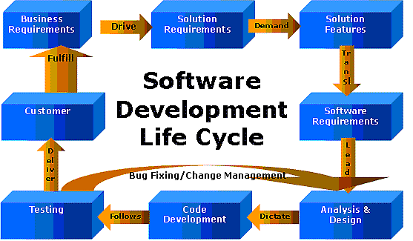

**Figure 6.1: Software Development Life Cycle**

**Requirements**

Business requirements are gathered in this phase.  This phase is the main focus of the project managers and stake holders.  Meetings with managers, stake holders and users are held in order to determine the requirements.  Who is going to use the system?  How will they use the system?  What data should be input into the system?  What data should be output by the system?  These are general questions that get answered during a requirements gathering phase.  This produces a nice big list of functionality that the system should provide, which describes functions the system should perform, business logic that processes data, what data is stored and used by the system, and how the user interface should work.  The overall result is the system as a whole and how it performs, not how it is actually going to do it.

**Design**

The software system design is produced from the results of the requirements phase.  Architects have the ball in their court during this phase and this is the phase in which their focus lies.  This is where the details on how the system will work is produced.  Architecture, including hardware and software, communication, software design (UML is produced here) are all part of the deliverables of a design phase.

**Implementation**

Code is produced from the deliverables of the design phase during implementation, and this is the longest phase of the software development life cycle.  For a developer, this is the main focus of the life cycle because this is where the code is produced.  Implementation my overlap with both the design and testing phases.  Many tools exists (CASE tools) to actually automate the production of code using information gathered and produced during the design phase.

**Testing**

During testing, the implementation is tested against the requirements to make sure that the product is actually solving the needs addressed and gathered during the requirements phase.  Unit tests and system/acceptance tests are done during this phase.  Unit tests act on a specific component of the system, while system tests act on the system as a whole.

**SDLC METHDOLOGIES**

This document play a vital role in the development of life cycle (SDLC) as it describes the complete requirement of the system. It means for use by developers and will be the basic during testing phase. Any changes made to the requirements in the future will have to go through formal change approval process.

**SOFTWARE DEVELOPMENT PROCESS MODEL**

Software Development Process Models specifies various software development approaches defined and designed which are used/employed during development process of software. The Software Development Process Model used for this Project is SPIRAL MODEL.

**SPIRAL MODEL**

Spiral Model was defined by Barry Boehm in his 1988 article, “A spiral Model of Software Development and Enhancement”. This model was not the first model to discuss iterative development, but it was the first model to explain why the iteration models.

As originally envisioned, the iterations were typically 6 months to 2 years long. Each phase starts with a design goal and ends with a client reviewing the progress thus far. Analysis and engineering efforts are applied at each phase of the project, with an eye toward the end goal of the project.

The following diagram shows how a spiral model acts…

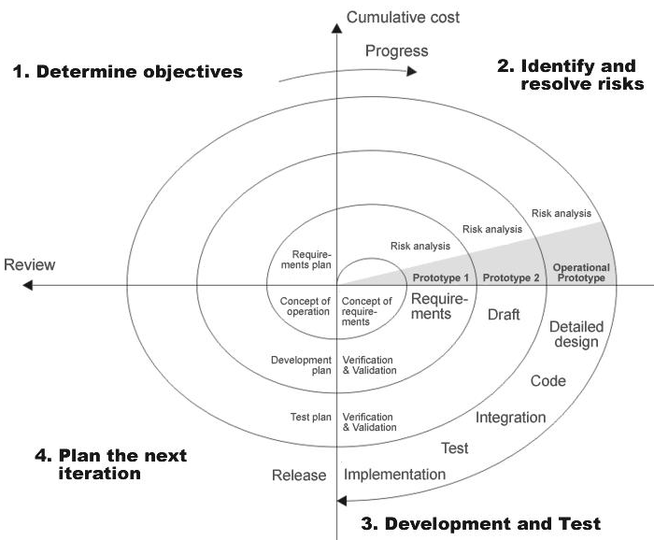

**Figure 6.2: Spiral Model**

**The Steps for Spiral Model can be generalized:**

* The new system requirements are defined in as much details as possible. This usually involves interviewing a number of users representing all the external or internal users and other aspects of the existing system.
* A preliminary design is created for the new system.
* A first prototype of the new system is constructed from the preliminary design. This is usually a scaled-down system, and represents an approximation of the characteristics of the final product.
* A second prototype is evolved by a fourfold procedure:

1. Evaluating the first prototype in terms of its strengths, weakness, and risks.
2. Defining the requirements of the second prototype.
3. Planning a designing the second prototype.
4. Constructing and testing the second prototype.

* At the customer option, the entire project can be aborted if the risk is deemed too great. Risk factors might involve development cost overruns, operating-cost miscalculation, or any other factor that could, in the customer’s judgment, result in a less-than-satisfactory final product.
* The existing prototype is evaluated in the same manner as was the previous prototype, and if necessary, another prototype is developed from it according to the fourfold procedure outlined above.
* The preceding steps are iterated until the customer is satisfied that the refined prototype represents the final product desired.
* The final system is constructed, based on the refined prototype.
* The final system is thoroughly evaluated and tested. Routine maintenance is carried on a continuing basis to prevent large scale failures and to minimize down time.

**6.2.EXISTING SYSTEM**

Many existing schemes provide scholarship based on financial or community wise. Even some schemes provide based on merit wise but they are not provide from the primary level Through this existing system the students efficiency cannot be measured. Because the scholarships are given based on their communities.

**6.3.PROPOSED SYSTEM**

Through this proposed system the students receives the scholarship purely based on talent. And students also focus more towards their academic progress in order to receive the scholarships. students will be motivated and try to work harder in order to get scholarships.

**6.4.USER REQUIREMENT DOCUMENTATION**

**Registration:**

|  |  |
| --- | --- |
| Use case ID | APGS_URD_01 |
| Use case Name | Registration |
| Description | It display the registration form |
| Primary Actors | All Users |
| Precondition | New Users |
| Post condition | Getting a valid ID and password |
| Frequency of Usage | One time |
| Alternative use case | N/A |
| Use Case Diagram | **..\UseCase diagram\USECASE.docx** |
| Attachments | N/A |

**Table6.4.1: URD- User registration**

**Login:**

|  |  |
| --- | --- |
| Use case ID | APGS_URD_02 |
| Use case Name | Login |
| Description | Display Login form to the user |
| Primary Actors | Registered users |
| Precondition | Users enter the valid ID and password |
| Post condition | Should display the home page |
| Frequency of Usage | Many times |
| Alternative use case | Forgot password |
| Use case Diagrams | **..\UseCase diagram\USECASE.docx** |
| Attachments | N/A |

**Table6.4.2: URD: User login**

**Scholarship :**

|  |  |
| --- | --- |
| Use case ID | APGS_URD_03 |
| Use case Name | Scholarship |
| Description | Verifying the eligible students |
| Primary Actors | Scholarship officer |
| Precondition | Valid the students |
| Post condition | Confirm all students who are eligible for scholarship |
| Frequency of Usage | Many Times |
| Alternative use case | N/A |
| Use case Diagrams | **..\UseCase diagram\USECASE.docx** |
| Attachments | N/A |

**Table6.4.3: URD: Scholarship**

**Institute:**

|  |  |
| --- | --- |
| Use case ID | APGS_URD_04 |
| Use case Name | Institute |
| Description | It contains details about the students |
| Primary Actors | Admin |
| Precondition | Students can register their scholarships through the institute |
| Post condition | Showing the all registered students details |
| Frequency of Usage | Many Times |
| Alternative use case | N/A |
| Use case Diagrams | **..\UseCase diagram\USECASE.docx** |
| Attachments | N/A |

**Table6.4.4: URD: Institute**

**Student:**

|  |  |
| --- | --- |
| Use case ID | APGS_URD_05 |
| Use case Name | Student |
| Description | Identify which scholarships are available for their qualification |
| Primary Actors | Students |
| Precondition | Apply for the scholarships |
| Post condition | Getting the scholarships |
| Frequency of Usage | Many Times |
| Alternative use case | N/A |
| Use case Diagrams | **..\Use Case diagram\USECASE.docx** |
| Attachments | N/A |

**Table6.4.5: URD: Student**

**Feedback:**

|  |  |
| --- | --- |
| Use case ID | APGS_URD_06 |
| Use case Name | Feedback |
| Description | It contains details about the student feedback |
| Primary Actors | Students |
| Precondition | Students can give the feedback |
| Post condition | Feedback must be considered by the admin |
| Frequency of Usage | Many Times |
| Alternative use case | N/A |
| Use case Diagrams | **..\UseCase diagram\USECASE.docx** |
| Attachments | N/A |

**Table6.4.6: URD: Feedback**

**6.5. SYSTEM REQUIREMENT SPECIFICATION**

**SRS (System Requirement Specification)**

SRS Id : PC_003

Name : student login

Description : Student must enter the details for their identity

Operations : 1. Mandatory Fields:

Login id, password

**SRS (System Requirement Specification)**

SRS Id : PC_004

Name : Admin login

Description : Admin can add, delete, and update the details .

Operations : 1. Mandatory Fields:

Verify students who are eligible for scholarship , delete students who are not eligible for the specified scholarship and add the institution details.

**SRS (System Requirement Specification)**

SRS Id : S_005

Name : Registration

Description : Every Student must enter the details for their identity

Operations : 1. Mandatory Fields:

Student No, Student name, Email, Mobile No, User Name, User Password, Address.

**SRS (System Requirement Specification)**

SRS Id : PG_007

Name : Registration

Description : Every Project Guide must enter the details for their identity

Operations : 1. Mandatory Fields:

**6.6. DATA FLOW DIGRAMS DIAGRAM**

Data Flow Diagram (DFD) illustrates the flow of information in a process based on the inputs and outputs. A DFD can be referred to as a Process Model. Additionally, a DFD can be utilized to visualize data processing or a structured design. A DFD illustrates technical or business processes with the help of the external data stored, the data flowing from a process to another, and the results. A designer usually draws a context-level DFD showing the relationship between the entities inside and outside of a system as one single step. This basic DFD can be then disintegrated to a lower level diagram demonstrating smaller steps exhibiting details of the system that is being modeled. Numerous levels may be required to explain a complicated system. Since the project includes no data base part for the transaction it is only required to mention the context level of the project work where it represents the no data base.

Data Flow represented by a thin line in the DFD and each data store has a unique name and square or rectangle represents external entities. Unlike detailed flowchart, Data Flow Diagrams do not supply detailed description of the modules but graphically describes a system’s data and how the data interact with the system.

To construct a Data Flow Diagram, we use

* Arrow
* Circles
* Open End Box
* Squares

**CONTEXT LEVEL (or) LEVEL -0**

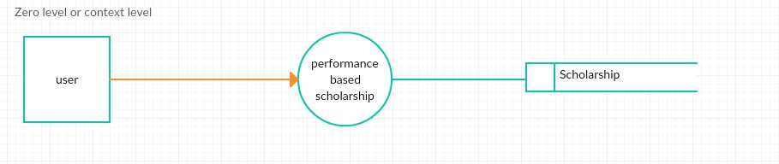

**Fig:6.6.1 context level DFD for Digital solution to integrate the scholarship scheme with performance**

**LEVEL-1**

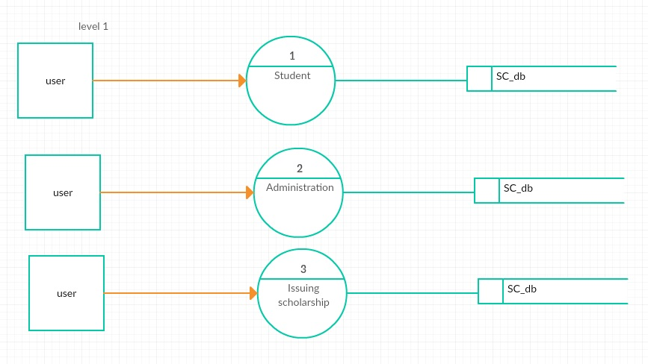

**Fig:6.6.2 Level-1 DFD for Digital solution to integrate the scholarship scheme with performance**

**LEVEL-2**

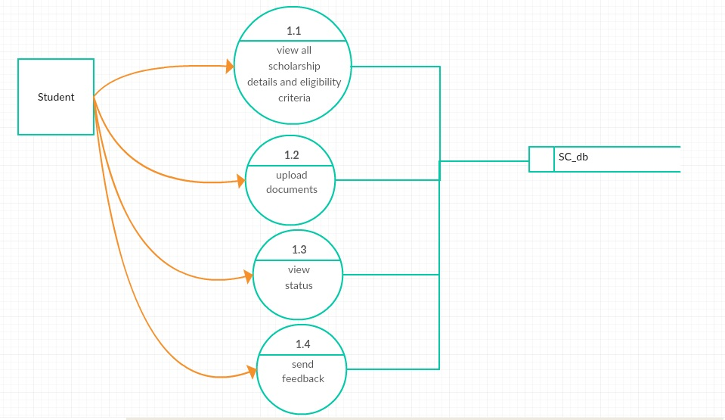

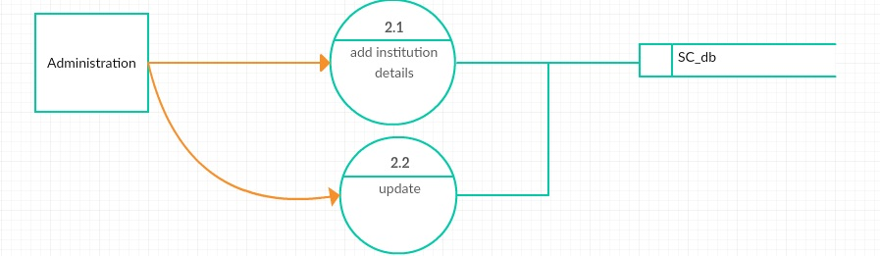

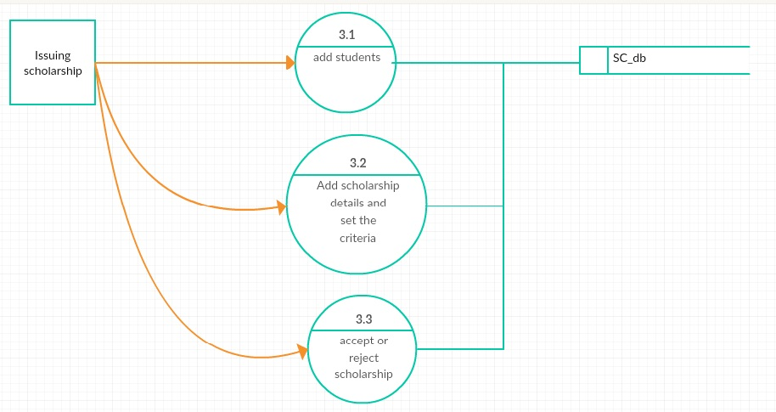**Fig:6.6.3 Level-2 DFD for Digital solution to integrate the scholarship scheme with performance**

**6.7. ER-DIAGRAM**

An entity-relationship model (ERM) is an abstract and conceptual representation of data. Entity-relationship modelling is a database modelling method, used to produce a type of conceptual schema or semantic data model of a system, often a relational database, and its requirements in a top-down fashion.

**Definition:**

An entity-relationship (ER) diagram is a specialized graphic that illustrates the interrelationships between entities in a database. ER diagrams often use symbols to represent three different types of information. Boxes are commonly used to represent entities. Diamonds are normally used to represent relationships and ovals are used to represent attributes.

The set of primary components that are identified by the ERD are

* Data objects
* Relationships
* Attributes
* Various types of indicators.

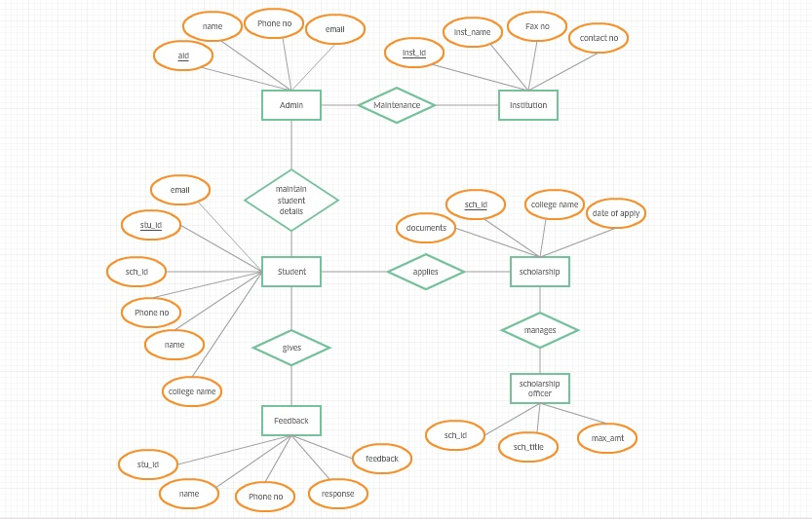

**Fig:6.7.1 ER-diagram for Digital solution to integrate the scholarship scheme with performance**

**6. 8.DATA DICTIONARY**

Data Dictionary in a database management system is a file that defines the basic organization of a database. A data dictionary contains a set of all files in the database, the number of records in each, and the names and types of each field in the record etc. Most database management systems keep the data dictionary hidden from users to prevent them from accidently destroying its contents. Data dictionaries do not contain any actual data from the database, only book keeping information for managing it. Without data dictionary, however, a database management system cannot access data from the database.

Analysts use data dictionaries for five important reasons:

1. To manage the detail in large system.

2. To communicate a common meaning for all system elements.

3. To document the features of the system.

4. To facilitate analysts of details in order to evaluate characteristics and determine where system changes would be made.

5. To locate errors and commissions in the system.

The data dictionary means what we have to use to store the information. In this Automatic Project Guidance System application normally used to dictionaries or tables that are ,

1. Admin
2. Student registration
3. Scholarship
4. Scholarship officer
5. Institution
6. Feedback

|  |  |  |  |  |  |
| --- | --- | --- | --- | --- | --- |
| SNO | COLUMNNAME | DESCRIPTION | TYPE | SIZE | CONSTRAINT |
| 1 | Name | User name | Varchar2 | 20 | Not null |
| 2 | Stu-id | Id of the student | Varchar2 | 40 | Primary key |
| 3 | Dob | Date of birth | Date | 20 | Not null |
| 4 | Password | Security password | Varchar2 | 20 | Not null |
| 5 | Mobile no | User phone number | Varchar2 | 10 | Not null |
| 6 | Address | Student address | Varchar2 | 20 | Not null |
| 7 | A-name | Admin name | Varchar2 | 20 | Not null |
| 8 | Sch-id | Scholarship id | Varchar2 | 30 | Primary key |
| 9 | Email | Email of students | Varchar2 | 25 | Not null |
| 10 | Documents | Required documents | Varchar2 | 30 | Not null |
| 11 | Inst-name | Name of institution | Varchar2 | 50 | Not null |
| 12 | Confirm password | Retype password | Varchar2 | 40 | Not null |
| 13 | Inst-id | Id of the college | Varchar2 | 16 | Primary key |
| 14 | A-id | Id of the admin | Varchar2 | 16 | Primary key |

Table 6.8.1: Data dictionary

**DATA DESIGN:**

**ADMIN**

|  |  |  |  |
| --- | --- | --- | --- |
| **S.NO** | **COLUMN NAME** | **DATA TYPE** | **CONSTRAINTS** |
|  | A-ID | Varchar2(10) | Primary key |
|  | A-NAME | Varchar2(20) | NOT NULL |
|  | EMAIL | Varchar2(10) | NOT NULL |
|  | PASSWORD | Varchar2(10) | NOT NULL |
|  | CONFIRM PASSWORD | Varchar2(10) | NOT NULL |
|  | ADRESS | Varchar2(20) | NOT NULL |
|  | PHONE NO | Number(10) | NOT NULL |

**Table 6.8.2: Admin**

**STUDENT REGISTRTION**

|  |  |  |  |
| --- | --- | --- | --- |
| **S.NO** | **COLUMN NAME** | **DATA TYPE** | **CONSTRAINTS** |
|  | STU-ID | Varchar2(10) | Primary key |
|  | STU-NAME | Varchar2(20) | NOT NULL |
|  | SURNAME | Varchar2(10) | NOT NULL |
|  | GENDER | Varchar2(5) | NOT NULL |
|  | DOB | Date | NOT NULL |
|  | ADDRESS | Varchar2(20) | NOT NULL |
|  | PHONE NO | Number(10) | NOT NULL |
|  | EMAIL | Varchar2(10) | NOT NULL |
|  | PASSWORD | Varchar2(10) | NOT NULL |
|  | CONFIRM PASSWORD | Varchar2(10) | NOT NULL |
|  | INST-NAME | Varchar2(10) | NOT NULL |
|  | SCH-ID | Varchar2(10) | NOT NULL |

**Table 6.8.3: Student registration**

**SCHOLARSHIP**

|  |  |  |  |
| --- | --- | --- | --- |
| **SNO** | **COLUMN NAME** | **DATA TYPE** | **CONSTRAINTS** |
|  | SCH-ID | Varchar2(10) | Primary key |
|  | STU-ID | Varchar2(10) | NOT NULL |
|  | COLLEGE NAME | Varchar2(20) | NOT NULL |
|  | DATE OF APPLY | Date | NOT NULL |
|  | DOCUMENTS REQUIRED | Varchar2(10) | NOT NULL |

**Table 6.8.4: Scholarship**

**INSTITUTION**

|  |  |  |  |
| --- | --- | --- | --- |
| **SNO** | **COLUMN NAME** | **DATA TYPE** | **CONSTRAINTS** |
|  | INST-CODE | Varchar2(10) | Primary key |
|  | INST-NAME | Varchar2(20) | NOT NULL |
|  | STU-ID | Varchar2(10) | NOT NULL |
|  | CONTACT NO | Number(10) | NOT NULL |
|  | FAX NO | Number(10) | NOT NULL |

**Table 6.8.5: Institution**

**SCHOLARSHIP OFFICER**

|  |  |  |  |
| --- | --- | --- | --- |
| **SNO** | **COLUMN NAME** | **DATA TYPE** | **CONSTRAINTS** |
|  | SO-ID | Varchar2(10) | Primary key |
|  | SCH-ID | Varchar2(10) | NOT NULL |
|  | SO-NAME | Varchar2(10) | NOT NULL |
|  | MAX-AMOUNT | Number(10) | NOT NULL |

**Table 6.8.6: Scholarship officer**

**FEED BACK**

|  |  |  |  |
| --- | --- | --- | --- |
| **S.NO** | **COLUMN NAME** | **DATA TYPE** | **CONSTRAINTS** |
|  | MOBILE NUMBER | Nnmber2(10) | Primary key |
|  | STU-ID | Varchar2(10) | NOT NULL |
|  | STU-NAME | Varchar2(20) | NOT NULL |
|  | FEED BACK | Varchar2(30) | NOT NULL |
|  | RESPONSE | Varchar2(30) | NOT NULL |

**Table 6.8.7: Feedback**

7. SYSTEM ENVIRONMENT

7.1. SOFTWARE REQUIREMENT

Operating System : Windows 8.1

User Interface : HTML, CSS

Client-side Scripting : JavaScript

Programming Language : Java

Web Applications : JDBC, JSP

Database : Oracle 10g

Server Deployment : Tomcat 8.5

7.2. HARDWARE REQUIREMENT

Processor : core I5

Hard Disk : 40GB

RAM : 512MB or more

**INTRODUCTION TO JAVA:**

**About Java:**

Initially the language was called as “oak” but it was renamed as “java” in 1995.The primary motivation of this language was the need for a platform-independent (i.e. architecture neutral) language that could be used to create software to be embedded in various consumer electronic devices.

* Java is a programmer’s language
* Java is cohesive and consistent
* Except for those constraint imposed by the Internet environment. Java gives the programmer, full control

Finally Java is to Internet Programming where c was to System Programming.

**Importance of Java to the Internet**

Java has had a profound effect on the Internet. This is because; java expands the Universe of objects that can move about freely in Cyberspace. In a network, two categories of objects are transmitted between the server and the personal computer. They are passive information and Dynamic active programs. in the areas of Security and probability. But Java addresses these concerns and by doing so, has opened the door to an exciting new form of program called the Applet.

**Application**

An application is a program that runs on our Computer under the operating system of that computer.

**Java Architecture**

Java architecture provides a portable, robust, high performing environment for development. Java provides portability by compiling the byte codes for the Java Virtual Machine, which is then interpreted on each platform by the run-time environment. Java is a dynamic system, able to load code when needed from a machine in the same room or across the planet.

**Compilation of code**

## When you compile the code, the Java compiler creates machine code (called byte code)for a hypothetical machine called Java Virtual Machine(JVM). The JVM is supposed t executed the byte code. The JVM is created for the overcoming the issue of probability. The code is written and compiled for one machine and interpreted on all machines .This machine is called Java Virtual Machine.

**JSP INTRODUCTION**

**Java Server pages (JSP):**

Java Server Pages (JSP) is a technology for developing web pages that support dynamic content which helps developers insert java code in HTML pages by making use of special JSP tags, most of which start with <% and end with %>.

A Java Server Pages component is a type of Java servlet that is designed to fulfil the role of a user interface for a Java web application. Web developers write JSPs as text files that combine HTML or XHTML code, XML elements, and embedded JSP actions and commands. Using JSP, you can collect input from users through web page forms, present records from a database or another source, and create web pages dynamically.

**What is JDBC?**

One can write a single program using the JDBC API, and the JDBC is a Java API for executing SQL, Statements(As a point of interest JDBC is trademarked name and is not an acronym; nevertheless, JDBC is often thought of as standing for Java Database Connectivity. It consists of a set of classes and interfaces written in the Java Programming language. JDBC provides a standard API for tool/database developers and makes it possible to write database applications using a pure Java API

Using JDBC, it is easy to send SQL statements to virtually program will be able to send SQL .statements to the appropriate database. The Combination of Java and JDBC lets a programmer writes it once and run it anywhere.

**What Does JDBC Do?**

**Simply put, JDBC makes it possible to do three things**

* Establish a connection with a database
* Send SQL statements
* Process the results
* JDBC Driver Types
* The JDBC drivers that we are aware of this time fit into one of four categories
* JDBC-ODBC Bridge plus ODBC driver
* Native-API party-java driver
* JDBC-Net pure java driver
* Native-protocol pure Java driver

An individual database system is accessed via a specific JDBC driver that implements the java.sql.Driver interface. Drivers exist for nearly all-popular RDBMS systems, through few are available for free. Sun bundles a free JDBC-ODBC bridge driver with the JDK to allow access to a standard ODBC, data sources, such as a Microsoft Access database, Sun advises against using the bridge driver for anything other than development and very limited development.

**ORACLE**

Oracle is a relational database management system, which organizes data in the form of tables. Oracle is one of many database servers based on RDBMS model, which manages a seer of data that attends three specific things-data structures, data integrity and data manipulation.

With oracle cooperative server technology we can realize the benefits of open, relational systems for all the applications. Oracle makes efficient use of all systems resources, on all hardware architecture; to deliver unmatched performance, price performance and scalability. Any DBMS to be called as RDBMS has to satisfy Dr.E.F.Codd’s rules.

Oracle Database is the first database designed for enterprise grid computing, the most flexible and cost effective way to manage information and applications.

The database has logical structures and physical structures. Because the physical and logical structures are separate, the physical storage of data can be managed without affecting the access to logical storage structures.

**HTML**

Hypertext Markup Language (HTML), the languages of the world wide web (WWW), allows users to produces web pages that included text, graphics and pointer to other web pages (Hyperlinks).

HTML is not a programming language but it is an application of ISO Standard 8879, SGML (Standard Generalized Markup Language), but Specialized to hypertext and adapted to the Web. The idea behind Hypertext one point to another point. We can navigate through the information based on out interest and preference. A mark-up language is simply a series of items enclosed within the elements should be displayed

**ADVANTAGES:-**

* A HTML document is small and hence easy to send over the net. It is small because it does not include formatted information.
* HTML is platform independent

HTML tags are not case-sensitive.

**JAVA SCRIPT**

The JavaScript is a compact, object-based scripting language for developing client and server internet applications. Netscape Navigator 2.0 interprets JavaScript statements embedded directly in an HTML page. And Livewire enables you to create server-based applications similar to common gateway interface (CGI) programs.

In a client application for Navigator, JavaScript statements embedded in an HTML Page can recognize and respond to user events such as mouse clicks form Input and page navigation.

For example, you can write a JavaScript function to verify that users enter valid information into a form requesting a telephone number or zip code. Without any network transmission, an Html page with embedded Java Script can interpret the entered text and alert the user with a message dialog if the input is invalid or you can use JavaScript to perform an action (such as play an audio file, execute an applet, or communicate with a plug-in) in response to the user opening or exiting a page.

**8. SYSTEM DESIGN**

**8.1 HIGH LEVEL DESIGN**

**UNIFIED MODELING LANGUAGE:**

The Unified Modelling Language allows the software engineer to express an analysis model using the modelling notation that is governed by a set of syntactic semantic and pragmatic rules.

A UML system is represented using five different views that describe the system from distinctly different perspective. Each view is defined by a set of diagram, which is as follows.

* + User Model View
    1. This view represents the system from the user’s perspective.
    2. The analysis representation describes a usage scenario from the end-users perspective.
  + Structural model view
    1. In this model the data and functionality are arrived from inside the system.
    2. This model view models the static structures.
* Behavioural Model View

It represents the dynamic of behavioral as parts of the system, depicting the interactions of collection between various structural elements described in the user model and structural model view.

* Implementation Model View

In this the structural and behavioral as parts of the system are represented as they are to be built.

**8.1.1 Class Diagram**

Class diagrams are the backbone of almost every object oriented method, including UML. They describe the static structure of a system.

**Contents:**

* Classes
* Interfaces
* Collaborations
* Dependency, generalization and association relationships

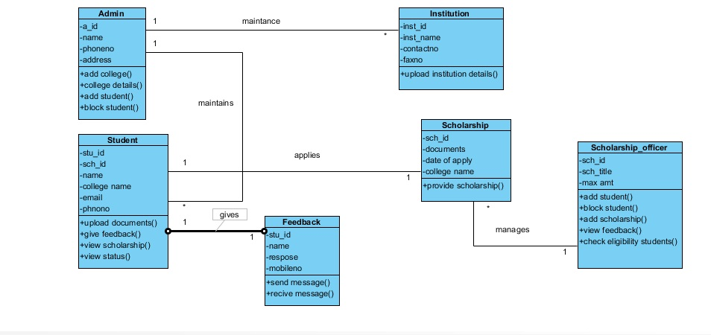

**Figure 8.1.1.1Class diagram for Digital solution to integrate the scholarship scheme with performance**

**8.1.2 Sequence Diagram**

A sequence diagram is used to trace the execution of a scenario in the same context as a communication diagram.

The components used in the Sequence diagram.

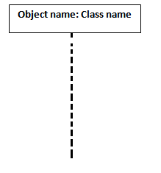

The main component is an object of the class with time line indicating the life line of the object

A stimulus indicates object function calls from each objects with respective parameters

* Environmental Model View

In this the structural and behavioral aspects of the environment in which the system is to be implemented are represented.

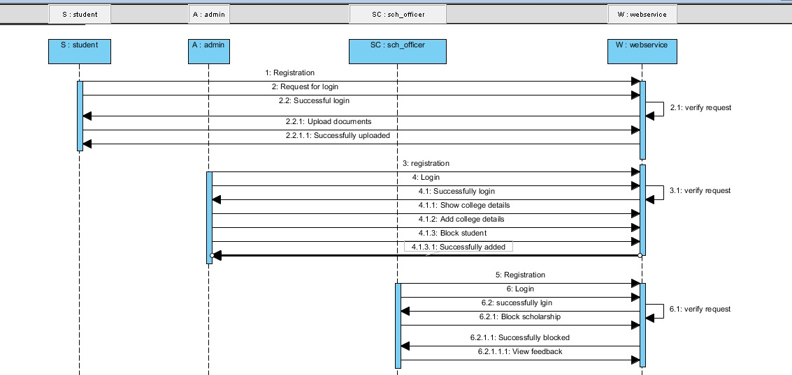

**Figure 8.1.2.2 Sequence diagram for Digital solution to integrate the scholarship scheme with performance**

**8.1.3. Collaboration Diagram**:

Collaboration diagrams represent interactions between objects as a series of sequenced messages. Collaboration diagrams describe both the static structure and the dynamic behavior of a system.

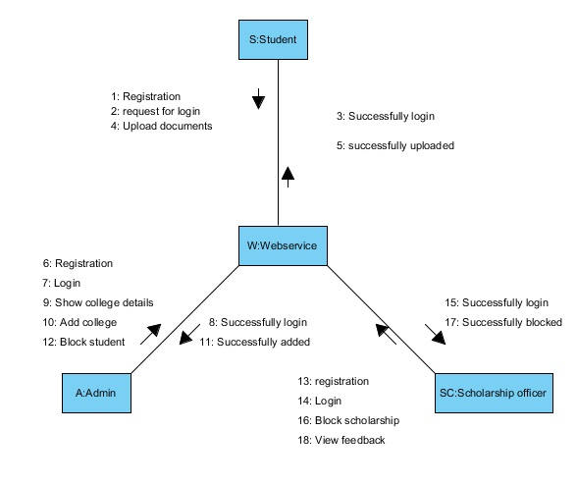**Figure 8.1.3.1 Collaboration Diagram Digital solution to integrate the scholarship scheme with performance**

UML is specifically constructed through two different domains they are:

* UML Analysis modeling, this focuses on the user model and structural model views of the system.
* UML design modeling, which focuses on the behavioral modeling, implementation modeling and environmental model views.

**8.1.4 Use case Diagram**

Use case Diagrams represent the functionality of the system from a user’s point of view. Use cases are used during requirements elicitation and analysis to represent the functionality of the system. Use cases focus on the behavior of the system from external point of view.

Actors are external entities that interact with the system. Examples of actors include users like administrator, bank customer …etc., or another system like central database.

* Use case diagrams are used to depict the context of the system to be built and the functionality provided by that system. They depict who (or what) interacts with the system. They show what the outside world wants the system to do.

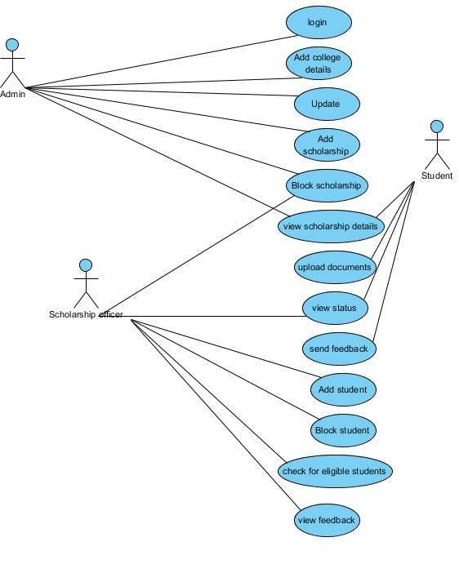

**Figure 8.1.4.1 Use case Diagram for Digital solution to integrate the scholarship scheme with performance**

**8.1.5 Activity Diagram**

Activity diagrams provide visual depictions of the flow of activities, whether in a System, business, workflow, or other process. These diagrams focus on the activities that are performed and who (or what) is responsible for the performance of those activities. The elements of an activity diagram are action nodes, control nodes, and object nodes. There are three types of control nodes: initial and final (final nodes have two varieties, activity final and flow final), decision and merge, and fork and join.

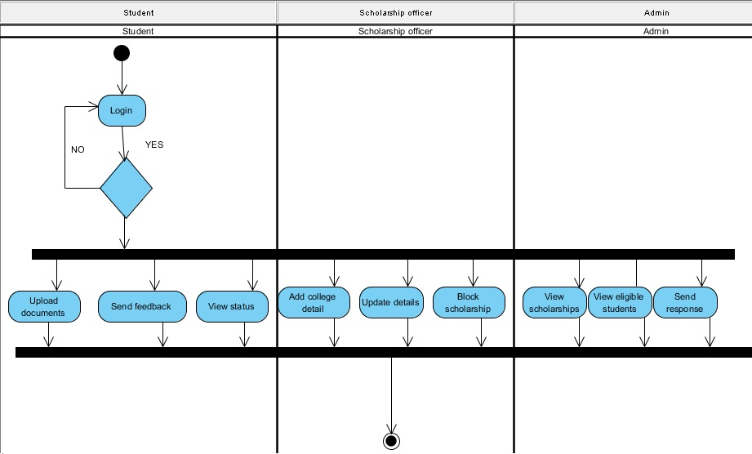

**Fig.No-8.1.5.1: Activity Diagram for Digital solution to integrate the scholarship scheme with performance**

**8.1.6. State chart diagram**

A Statechart diagram describes a state machine. Now to clarify it state machine can be defined as a machine which defines different states of an object and these states are controlled by external or internal events.

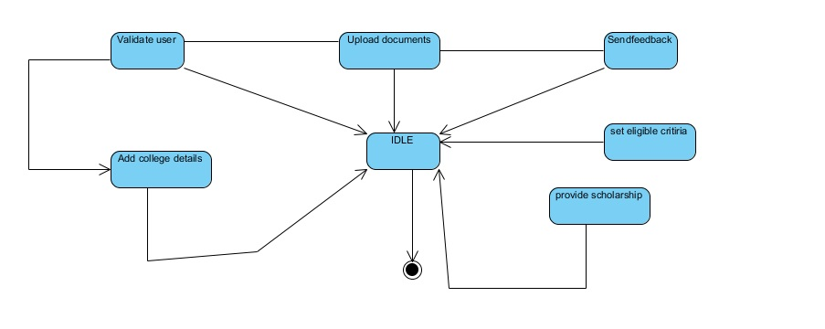

**Fig.No-8.1.6.1: State chart Diagram for Digital solution to integrate the scholarship scheme with performance**

**8.1.7 Component Diagram:**

Component diagrams describe the organization of physical software components, including source code, run-time (binary) code, and executables

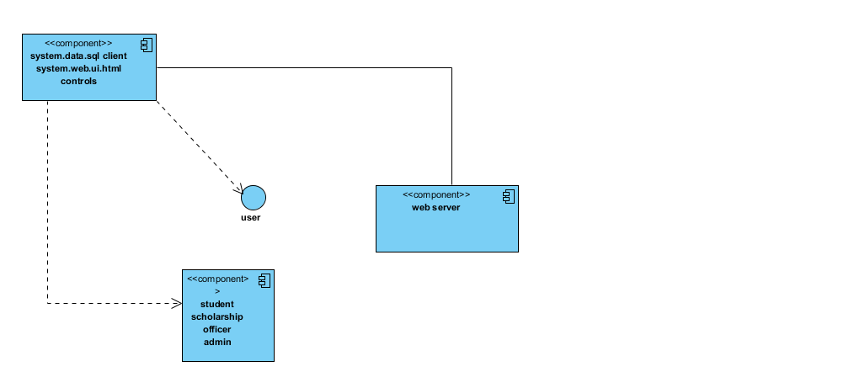

**Fig.No-8.1.7.1: Component Diagram for Digital solution to integrate the scholarship scheme with performance**

**8.1.8. Deployment Diagram**:

Deployment diagrams depict the physical resources in a system, including nodes, components, and connections.

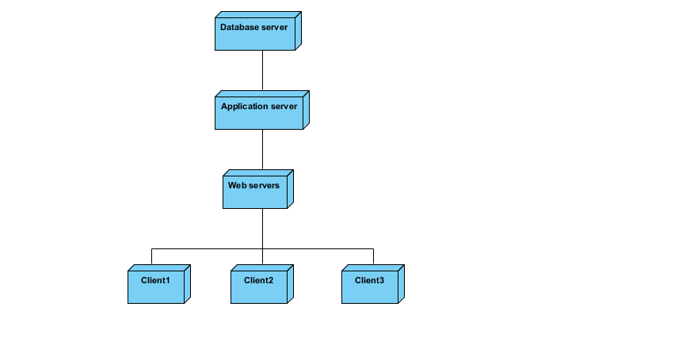

**Fig.No-8.1.8.1: Activity Diagram for Digital solution to integrate the scholarship scheme with performance**

**LOW LEVEL DESIGN**

**8.2.1 Low-level Design for Registration:**

**LLD Id: L_001**

**Name: Registration Form**

**Description:**

* **First Name**: **Text Box**

Maximum it contains 20 characters and Minimum contains 4 characters, no special characters, Digits are not allowed.

* **LastName**: **Text Box**

Maximum it contains 20 characters and Minimum contains 4 characters, no special characters, Digits are not allowed.

* **Email-Id**: **Text Box**

It should contain only one @ symbol and textbox size contain 20(size), no special characters are not allowed, except underscore (_) and @ symbol, digits are allowed.

* **Mobile no:**

Maximum it contains 10 numbers no special characters, characters are not allowed.

* **Login Name: Text Box**

Maximum contains 20characters and Minimum contains 4 character, no special characters Digits are not allowed.

* **Password**: **Text Box**

Maximum contains 10 characters and Minimum contain 2 character Digits are allowed. Special characters are allowed.

* **Address**:

Maximum it contains 100 characters and Minimum contains 10 characters, special characters, Digits are allowed.

**8.2.2 Low-level Design for Login:**

**LLD Id: L_002**

**Name: Login Form**

**Description:**

* **1. User Name: Text Box**

Maximum contains 20characters and Minimum contains 4 character, no special characters Digits are not allowed.

* **2. Batch no:**

Maximum contains 2digits and Minimum contains 4 digits, no special characters are not allowed.

* 3. **Password**: **Text Box** Maximum contains 10 characters and Minimum contain 2 character Digits are allowed. Special characters are allowed.

**9. IMPLEMENTATION**

**9.1 Screen Shorts**

**HOME PAGE**

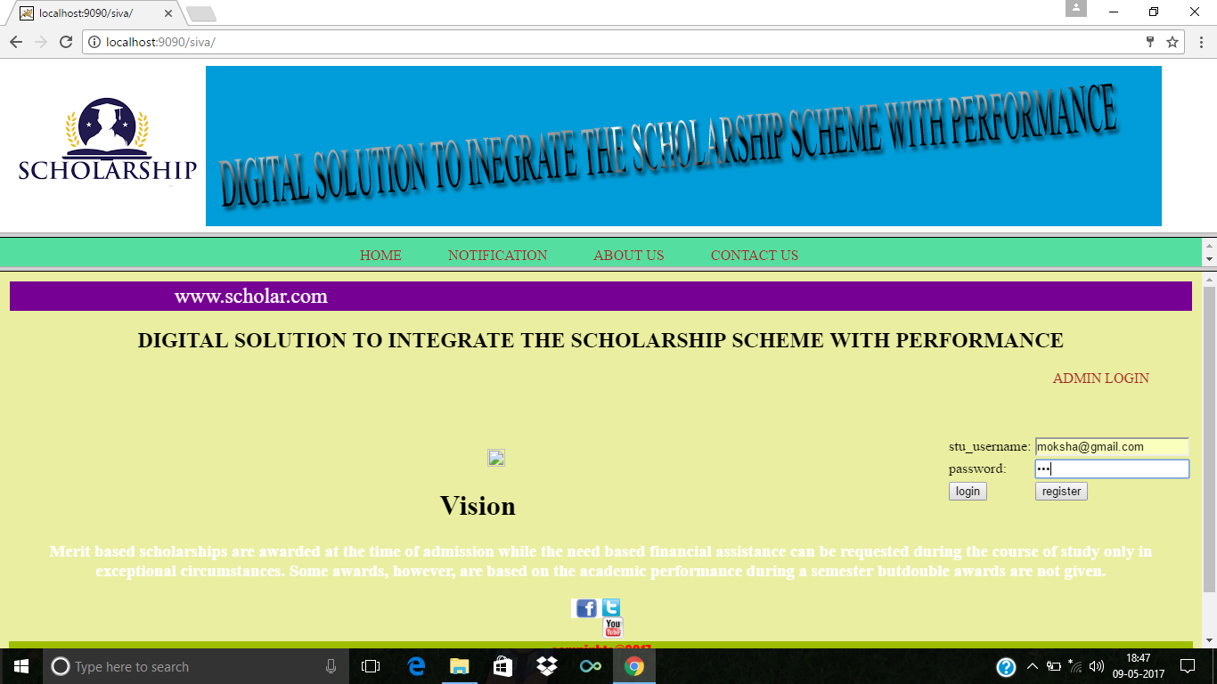

**Fig:9.1.1Student can login into the website by providing userid and password.**

**STUDENT REGISTRATION**

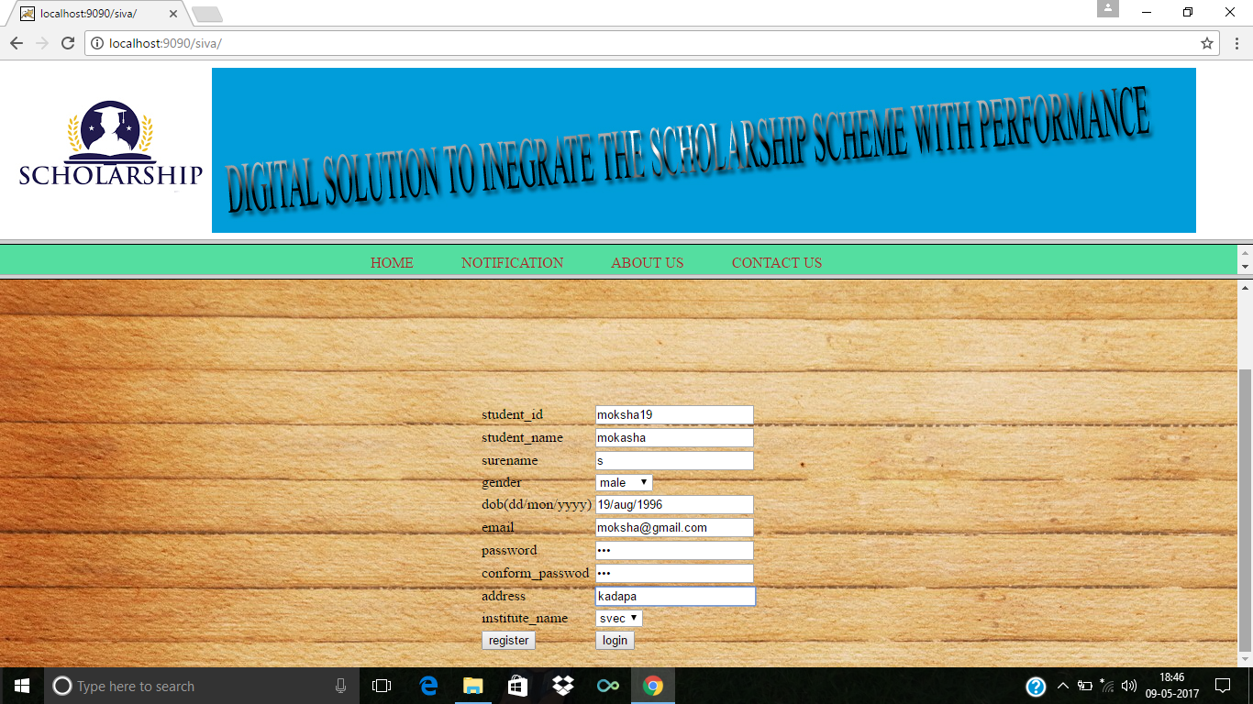

**Fig:9.1.2 Student can register into the website for login**.

**SUCCESFULL REGISTRATION**

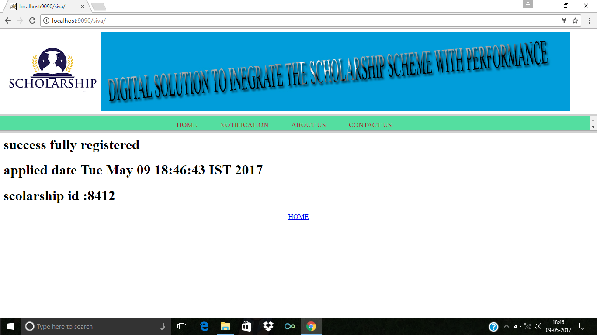

**Fig: 9.1.3 The student can registered and get unique scholarship id.**

**STUDENT VIEW PROFILE**

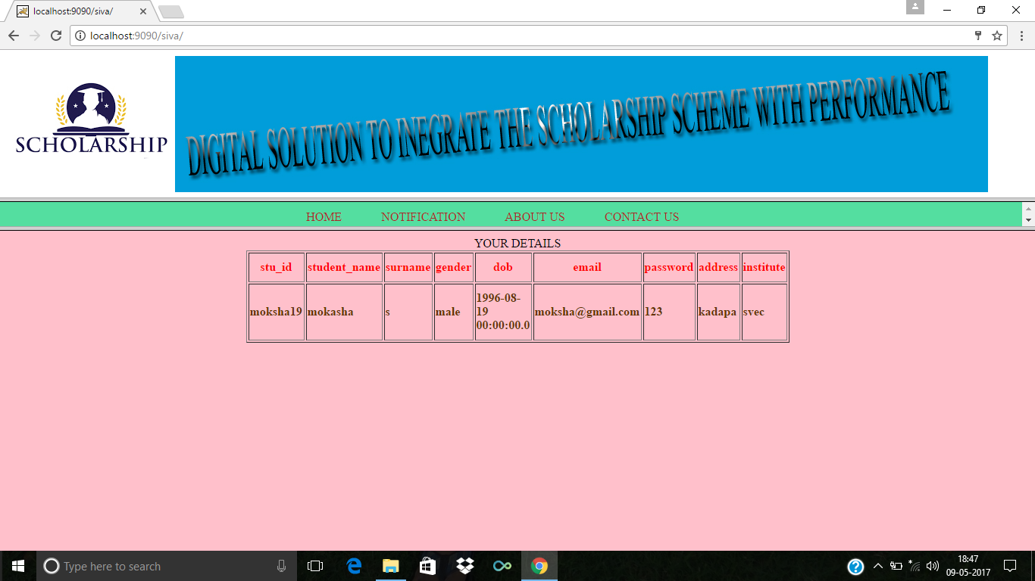

**Fig:9.1.4 The student can view their profile**

**UPLOAD DOCUMENTS**

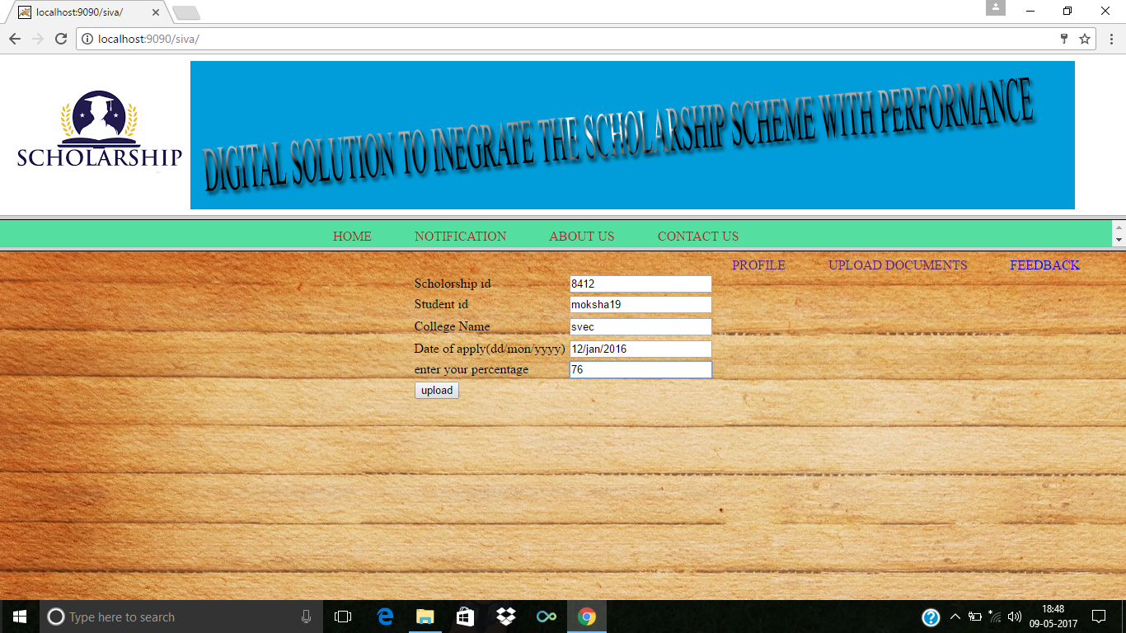

**Fig:9.1.5 The student can upload the documents for getting the scholarships**.

**GET NOTIFICATIONS**

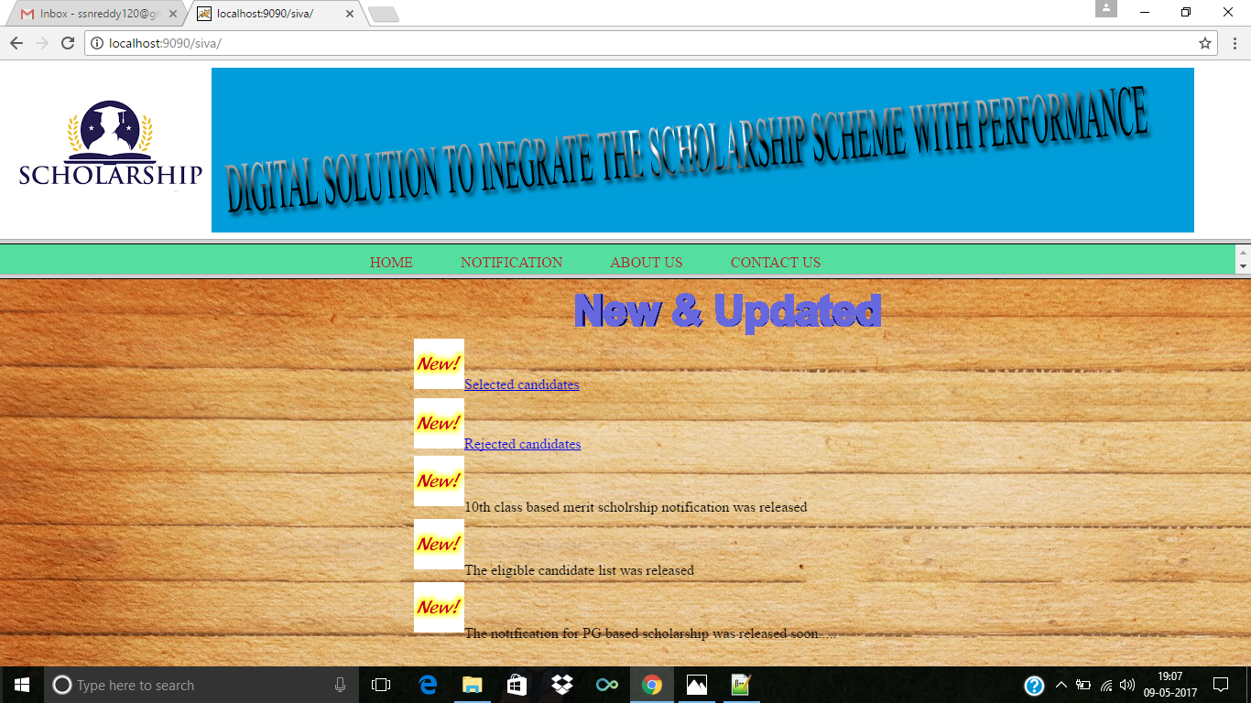

**Fig:9.1.6 The student can get notifications regarding the scholarships.**

**VIEW REJECTED CANDIDATES**

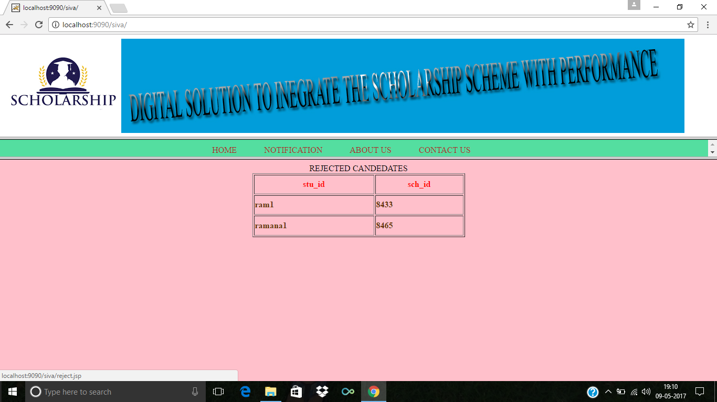

**Fig:9.1.7 The students view the rejected candidate list**

**GIVE FEEDBACK**

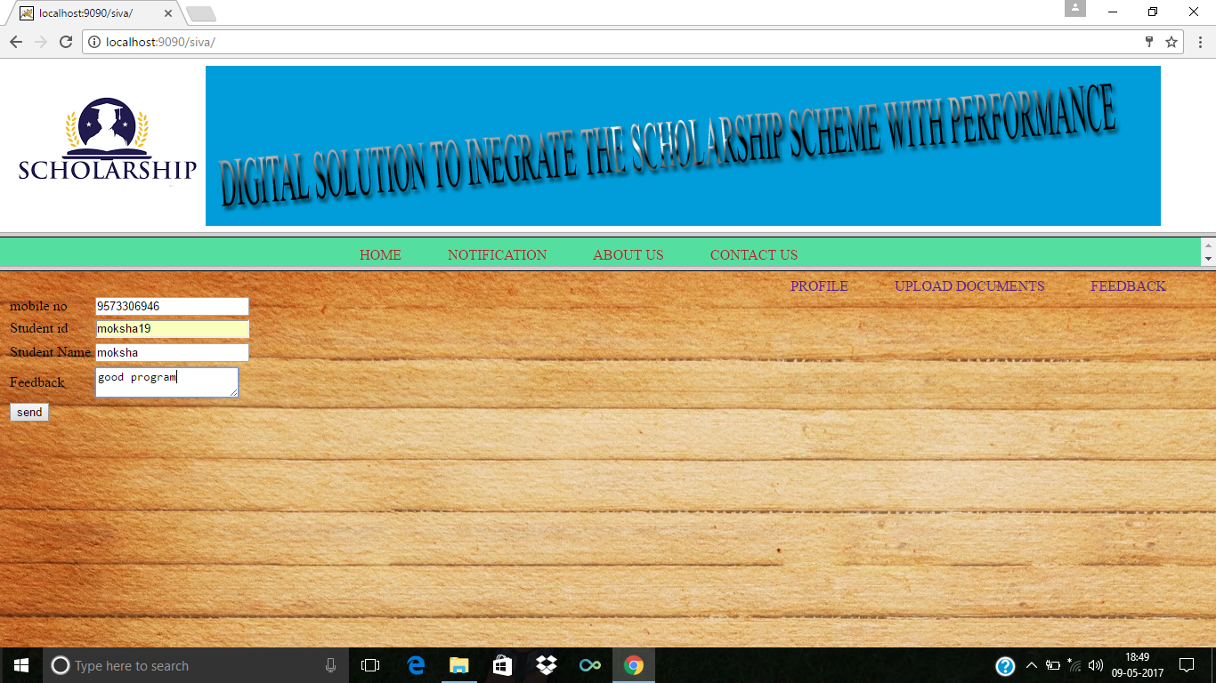

Fig:9.1.8 Student can give the feedback about the scholarships

ADMIN LOGIN

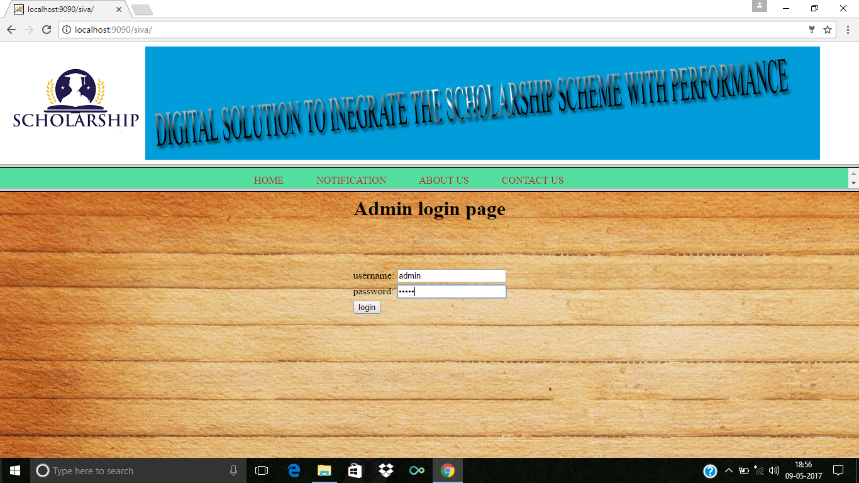

Fig:9.1.9 The admin can login into the website by providing the user id and password

ADD INSTITUTE DETAILS

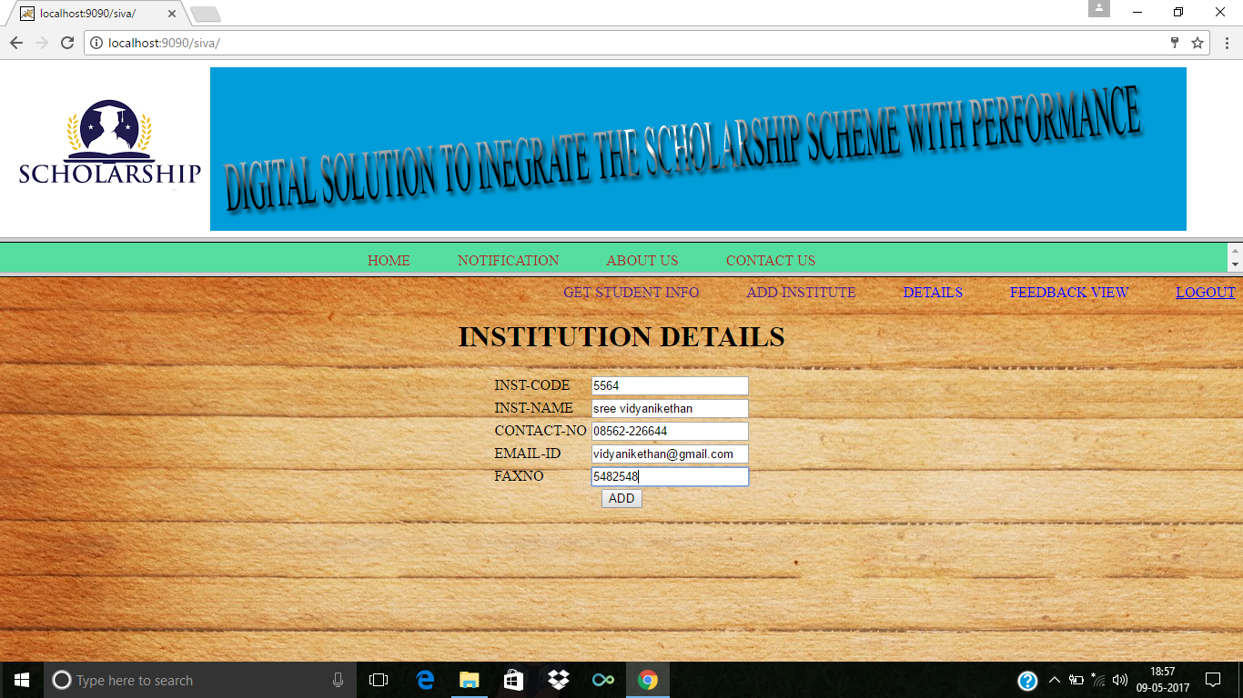

**Fig:9.1.10 Admin can add the institute details**

**10.REPORTS**

VIEW STUDENT DETAILS

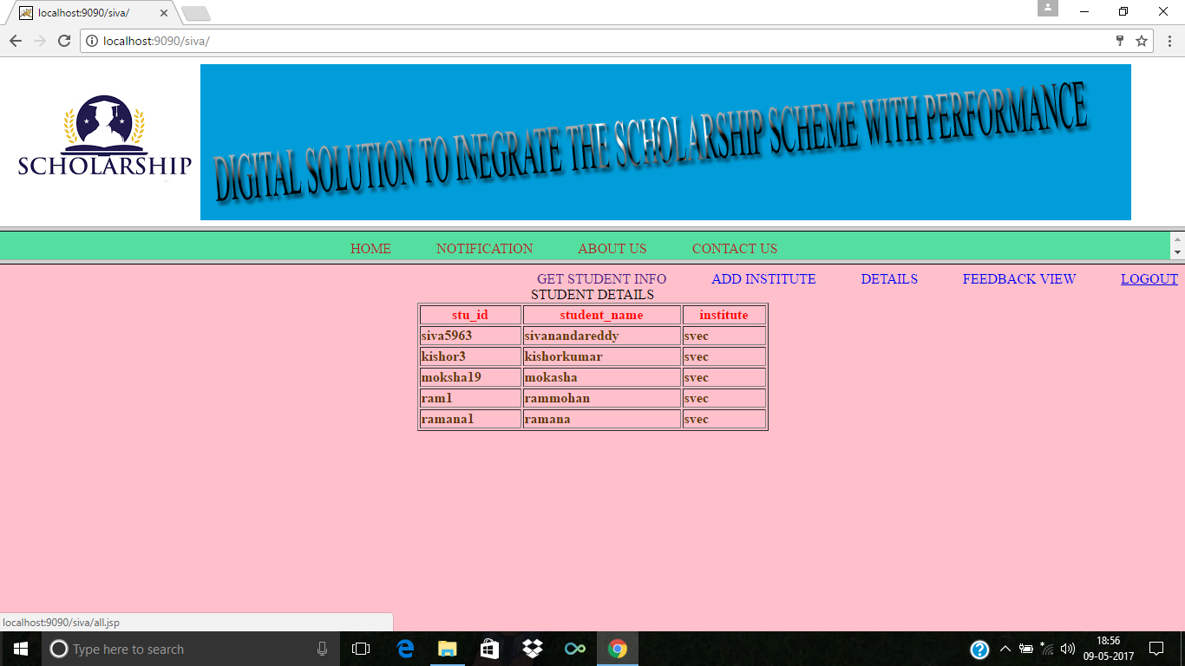

**Report10.1 The Admin can view the student details about how many students are applying fir the scholarship.**

**VIEWDOCUMENTDETAILS**

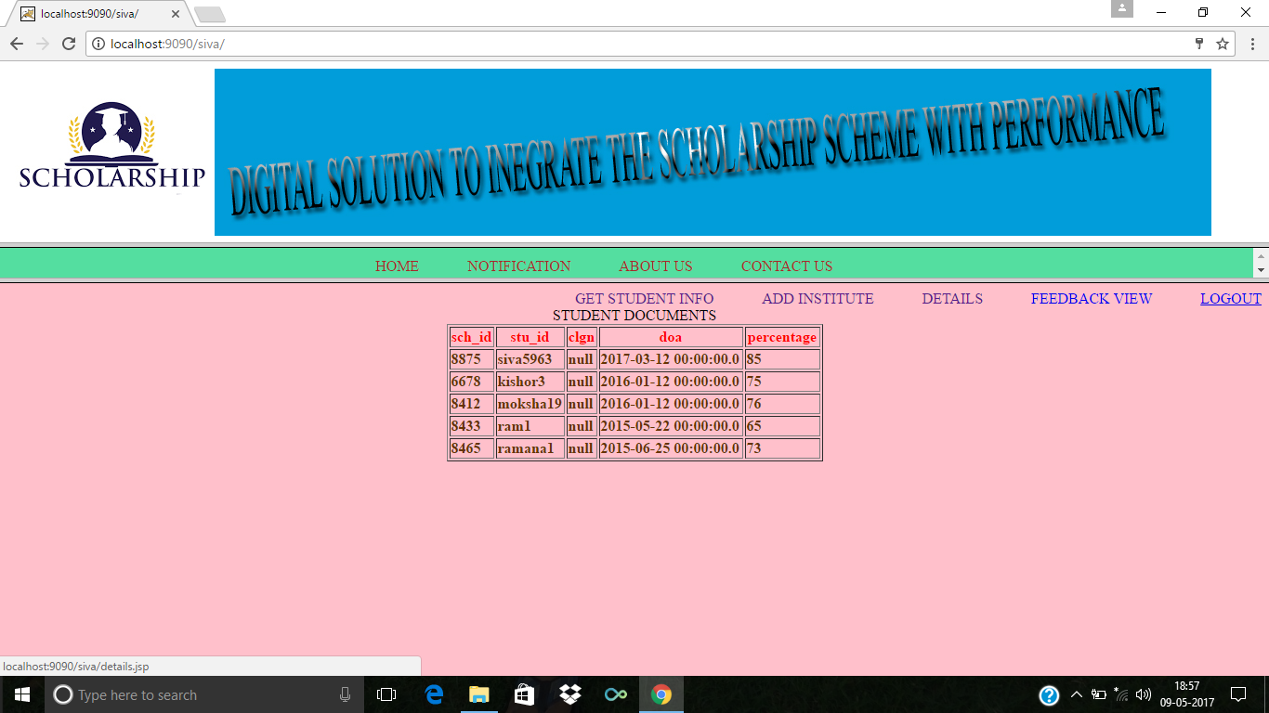

**Report 10.2. The admin can view the documents of students who are eligible for scholarships.**

**VIEW FEEDBACK**

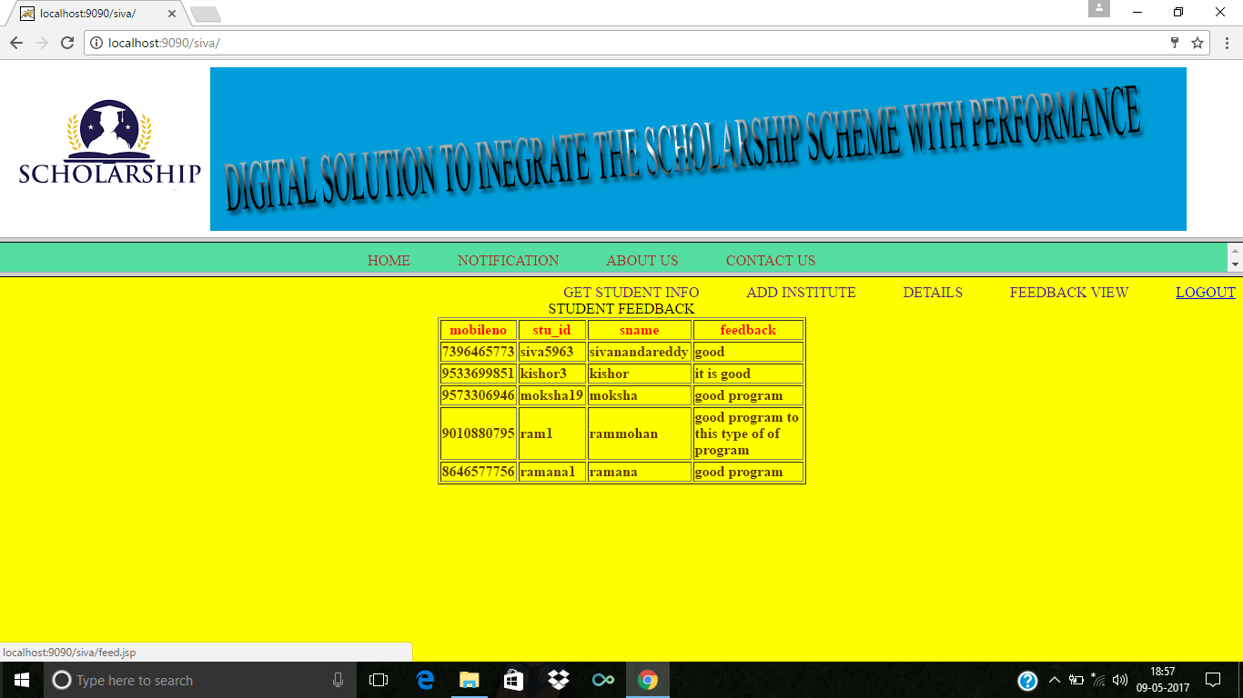

**Report 10.3 The admin can view the feedbcak given by the students**

**11. CONCLUSION**

The Digital solution to integrate the scholarship scheme with performance is developed using java and sql fully meets the objectives of the system for which ithas been developed.It has reached a stedy state where all bugs have been eliminated.The portal is operated at a high level of efficiency,the student and the guide associated with the portal understands its advantages.it was intended to solve as requirement specification.

**11.1 LIMITATIONS**

* The Project deals with the number of users,need to have efficient database.
* Extra management is needed
* The size of the datqabase is increase day by day increasing the load on the database backup and dataq maintaince activity.
* It works effecitively in latest browsers.

**11.2 FUTURE ENHANCEMENT**

It is not possible to develop a system that makes all the requirement of the user.User requirement keep changing as the system is being used.Some of the future enhancement that can be done to this system are:

**APPENDIX**

**A. User manual:**

Steps for running this program

* Load the required software’s with guidance of this manual
* The software’s required are

Jdk 1.8.0

Apache Tomcat 8.5

Oracle 11g

Install the jdk 1.8.0 in the system

* Install oracle 11g
* Create the database by clicking on database and deploy the tables in the new database
* Start the tomcat server services
* The application is loaded into the tomcat server
* Compile all java files
* Execution

**B. BIBLIOGRAPHY**

**REFERENCES**

**Book Resources**

1. Grady Booch, James Rumbaugh, Ivar Jacobson, “The Unified Modelling Language User’s Guide”, Second Edition, Pearson Education, 2004.
2. Hans Bergsten, O’reilly, “Java Server Pages”, Third Edition, December 2003.
3. Herbert Schildt, “The Complete Reference Java J2SE”, Tata McGraw Hill, 7th Edition, 2006.
4. Roger S.Pressman, “Software Engineering- A Practioners Approach”, McGraw-Hill, Fifth Edition, June 2000.

**Web Resources**

http://[www.vidyanikethan.edu](http://www.vidyanikethan.edu)

http://[www.tutorialspoint.com](http://www.tutorialspoint.com)

http://www.oracle.com